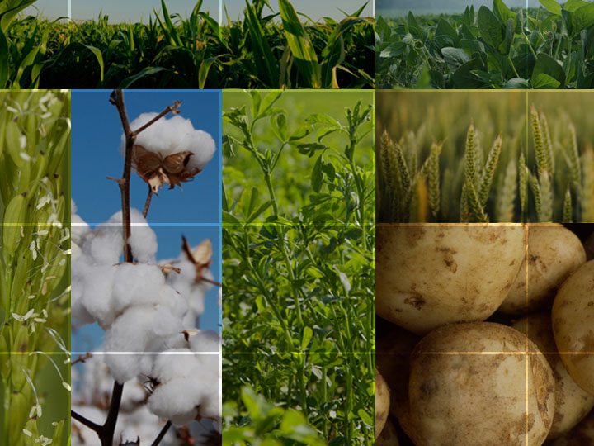

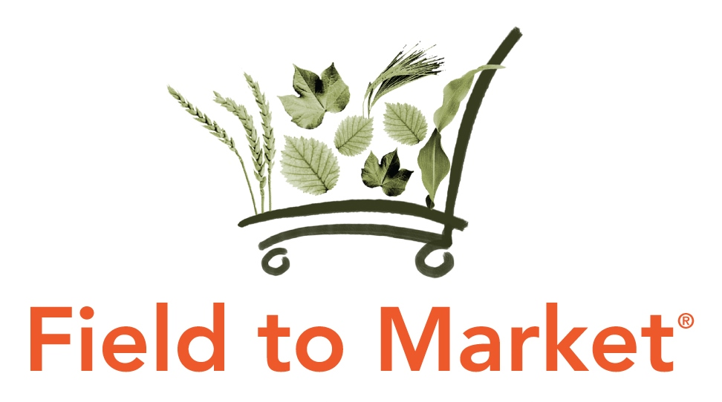
Plenary and General Assembly
Breakout Discussion Group Summaries
November 12, 2020

Field to Market June Plenary & General Assembly Meeting
Virtual Events
November 9-12, 2020

Field to Market’s virtual November Plenary and General Assembly Meeting convened 11 breakout group discussion to offer members smaller and more intentional networking opportunities around areas of shared interest. These discussions covered a diverse range of topics to explore both challenges and opportunities in scaling sustainable outcomes for agriculture. This document summarizes each of the 11 breakout discussions to provide shared learning across Field to Market’s membership.

LEADING WITH SCIENCE

What is needed in Soil Carbon Modeling and Measurement?
The breakout group reviewed some general background information on soil carbon research questions, measurement techniques, and an overview of models available to be applied in context relevant to Field to Market sustainability metrics. Several discussion questions were posed to the participants:
- What is most important to know to assess a field’s environmental sustainability?
  - Soil carbon content?
  - Soil carbon change?
  - Guidance on what practices lead to carbon increases?
- What are the most common questions about soil carbon that you hear from farmers? From others in the value chain?
- How should Field to Market work with emerging soil carbon market opportunities?

The group discussed the role of Field to Market as a convenor not only of diverse members of the value chain but also as a place where science meets practice for sustainability. Communications with farmers that just focus on carbon or emissions have less impact than those which can translate this into something tangible for the farmer – for example, focus on the nutrients gained/available to crops due to increases in soil organic matter, which has a direct implication for fertilizer planning. There was discussion of the value of connecting soil carbon to other indicators, including biodiversity and nutrient management, in addition to the connection into soil health.

Tools and Approaches to Improve Data Quality and Analysis of Continuous Improvements Projects

Participants were given suggestions about how to approach data quality and analysis for Fieldprint Platform data outputs, including a demo of an interactive web tool available to Continuous Improvement Project administrators. Participants indicated that they would consider hiring a third-party organization to assist with Fieldprint Platform data entry and possibly with data analysis. Field to Market might consider offering data analysis training to external data analysts to serve as a resource to Field to Market members.

How Remote Sensing Can Improve Data Quality and Assurance in Supply Chain Sustainability Initiatives

There is an interest from practitioners to better understand what is possible today with remote sensing in the agricultural sustainability space or if it can be applied from a practical perspective - economically, accurately, etc. For example, Field to Market is trying to better understand the practical applications of remotely sensed data as it relates to grower inputs and validation/verification of data.

The group discussed the active use of remote sensing in areas like detection or confirmation of specific management practices such as tillage and cover crop usage. Tools like Operations Tillage Information System (OpTIS) from CTIC, Dagan, and TNC offer offers an “… automated system to map tillage, residue cover, winter cover, and soil health practices using remote sensing data.” The group also touched on sources of land cover mapping such as the USDA Cropland Data Layer.

In addition to current use related to tillage practices or cover crops, there was discussion around how remotely sensed data could apply to validating in-field and off-field practices (e.g. filter strips). Related to this, remotely sense data can be useful as a means for low-cost certification in certain programs. There may not be a practical application in areas like detecting water use for rice production. In these cases, the use of soil moisture probes are more practical.

There is a tremendous amount of research going on in the remote sensing space, including at land grant universities. There is research around remote sensing coupled with AI, and unmanned aerial systems, which has helped to demonstrate or confirm the value or validity of certain practices or outcomes. There was some discussion around how real data is needed to “train” the models being developed.

From a producer perspective, it is important that organizations or systems leveraging remote sensing consider how their use offers value back to the producer or how producers perceive their use. In other words, the technology needs to be perceived as something helpful to growers productivity/profitability and not just a means to validate practices for certification schemes.

ENHANCING FARMER LIVELIHOODS

Exploring Creative Financing and Incentive Mechanisms to Scale Sustainable Agriculture

Participants explored a continuum of creative finance and incentive mechanisms and the challenges and opportunities in harnessing them to scale sustainable agriculture. The group evaluated the assumption that monetary incentives must be in place to scale sustainable agriculture, with several participants demonstrating that technical assistance can be achieved at a lower cost and often produce lasting benefits beyond a premium or financial incentive. Some participants observed that growers that collect data and have a conservation plan demonstrate better agronomic performance.

The group also discussed several examples of cost-share structures for both growers and trusted advisers around cover crop adoption. In some instances, companies are providing monetary support for all grower participating in projects, but the amount can vary significantly from nominal financial support to $25/acre. One participant mentioned that a monetary incentive for cover crops is not needed if the grower fully understand and can realize the intended benefits through better technical assistance. However, financial support for the upfront capital investment related to seed costs was viewed positively.

Pay for performance was highlighted as a suggested model, with the example of the STAR program being used to evaluate performance on water quality, with a higher payment for a higher score. Several raised the challenge of how you incentivize the grower across the full rotation and not just individual crops. A challenge that is compounded by what many have observed as an inverse relationship between financial incentives and the long-term continuity of practice adoption, finding that the higher the incentive, the less likely the farmer will continue the practice once the incentive ends.

Participants shared that significant interest is being generated by the next administration’s proposal for carbon markets; however, clarity around public and private sector roles is still needed. The challenge of lack of value for farmers in ecosystem service projects was highlighted as being a barrier. In some instances, these projects generate less than $5/acre to the farmer with the rest going to verification and assurance costs. For instance, there would be more value in a $10/acre direct cost-share program. As more players emerge in the ecosystem service space, concerns were also raised about double counting and increasing competition for farmers who might need to better understand the benefits and challenges of various approaches before signing on.

Risk reduction was suggested as another option to consider beyond monetary incentives. Many participants felt this strategy holds promise and is more tangible than carbon payments. However, many mechanisms in this area are constrained by parameters within the federal crop insurance program.

Participants also discussed the role of lenders potentially offering lower rate to fund green bonds (participants highlight examples in other countries). In the U.S finance system, many farmers rely on local banks, which do not have the scale or ability to amend actuarial tables. The idea would be to work with multinational banks who may have more appetite and potential willingness to partner with local institutions. Adjusting rates on a line of credit was also highlighted as a potential game changer if sustainable practices are considered. Participants shared that many input providers are also provide lending support. In both cases, this mechanism relies upon good actuarial data, which is a gap that needs to be addressed.

Participants shared that economic case studies are important for articulating the benefits to growers, but nothing works like word-of-mouth and seeing success from a neighbor. Demonstrating increased land value from conservation practices was also an opportunity emphasized, with examples of influencing lease arrangements with non-operating landowners if they understand the benefits of conservation practices. Examples of building capacity among rural appraisers and farm managers to understand, assess and evaluate sustainability performance of agricultural assets was highlighted as a significant opportunity for further exploration as 70% of land is leased in some areas of the country.

Field to Market’s Innovative Finance Workgroup was highlighted as a new workstream that will explore and expound upon the incentive mechanisms discussed. The workgroup will create a roadmap of strategies for Field to Market members to consider in their efforts to scale sustainable outcomes for agriculture. Workgroup participants will be announced in January and meet monthly throughout 2021.

Best Practices for Conducting Farm Economic Case Studies for Conservation Adoption

This session, led by Vincent Gauthier, Working Lands Research Analyst for EDF began with round-robin introductions by attendees. Vincent gave a 20-minute presentation that covered the gaps in understanding the financial impacts of conservation agriculture and how filling those gaps can help projects structure financial incentives to best support farmers transitioning to new conservation practices.

Earlier this year, EDF looked at 34 economic case studies conducted by 11 organization and found very little that could be compared between studies. Combined, the studies provide a small evidence base to support the financial case, making it hard to come to any reliable conclusions. One of the challenges in developing good case studies is insufficient recordkeeping by farm operations. EDF will be releasing a best practice guide in the coming weeks called “Measuring the Financial Outcomes of Agricultural Conservation Practices” that offers guidance for organizations on developing new studies that are comparable across scenarios.

After Vincent’s presentation, the group discussed how profitability data can be helpful in our work and ways we can contribute data to future studies. The group discussed the value of partnerships and emphasized the need to have the right partners on board for a successful financial analysis. Analyzing yield lags and start-up costs for implementing new practices is necessary and communicating that information to both farmers, lenders and impact investors will open the door for more creative financing opportunities.

PARTNERING FOR IMPACT

Exploring Scope 3 Greenhouse Gas Emissions Reporting for Agricultural Supply Chains

Field to Market members are navigating Scope 3 reporting requirements that are being defined by multiple organizations. From baseline definitions to additionality and required timeframes, the current landscape allows for numerous interpretations. Overall, transparency in approach emerged as one of the most important principles in credibly measuring and reporting reductions. Given that this space is evolving and different schemes will be introducing new guidance in 2021, Field to Market can best empower its members by focusing on developing guidance for how to use the Fieldprint Platform and Continuous Improvement Projects for Scope 3 reporting.

Cross-Sector Collaborations to Advance Feed Sustainability
This breakout discussion explored solutions for advancing feed sustainability. The group examined trends such as increased scrutiny from consumers, advocacy organizations and investors on feed sustainability, as well as how Field to Market’s programs fit into the broader landscape of existing efforts focused on assessing feed sustainability. With only a handful of Field to Market’s 69 active Continuous Improvement Projects focused on feed, Field to Market members discussed the biggest challenges impeding the industry’s ability to advance sustainable feed and shared ideas on the greatest opportunity for how Field to Market members might accelerate action in the protein sector to mirror the level of engagement from the food and beverage sectors.

When discussing the biggest challenges, participants described the need for financial incentives to support producers and to improve farmers’ perception of practices that can improve the sustainability of feed, which can also lead to improved productivity and profitability. The need to assist farmers with the economic analysis to better understand the benefits of specific conservation practices was highlighted as a gap that must be addressed. Other challenges include fragmented demand signals across the supply shed and the challenge of scaling data collection at a meaningful level across producers to enable actionable insights for key supply sheds.

Participants also outlined what they envision as the biggest opportunities to accelerate action. One recommendation is that the supply chain more directly connect with farmers to explain their motivations and interest in sustainable feed and to demonstrate a willingness to invest upstream to enable change. Concerns were raised that often companies requesting sustainability attributes rarely engage directly with farmers and there is a perception that the value is reserved only for the company rather than actually trying to help farmers improve and build the trust needed to enable change. Another recommendation was that we need to unite the protein sector on a shared feed sustainability strategy across beef, pork, poultry and dairy and more education is needed across the sector and Field to Market’s membership on opportunities for collaboration.

Key Ingredients for Successful Project Design and Implementation

After a quick overview of the Continuous Improvement Project framework, this breakout group dug into identifying the “key ingredients” for success. Overall, the group highlighted the importance of multi-stakeholder collaboration, having a local expert as part of the project team, and the importance of connecting to the value proposition of why this is important to both the farmers and project sponsors.

Recognizing and partnering with local expertise is essential for outreach, implementation, and building on trusted relationship with farmers. These local experts include farmer representatives, local agronomists, ag retailers, state level grower organizations and local NGOs. Empowering these “boots on the ground” partners with information on interpreting Fieldprint analysis is critical for success. These local experts have the connections, community and cultural awareness to drive change by working with the farmer leaders within these communities that can then help move the entire community towards sustainability.

The other key ingredient identified by our grower sector representatives was the importance of language. The overall goal is to have clear and consistent messaging for farmers including a need for a one-page description for each project. Support for the development of this messaging can be offered by grower sector communication leads and the local expert advisers. “Get out of the buzz words and focus on the environmental outcomes,” was the core message for this group –using terminology that defines actions at the field level.

CELEBRATING SUSTAINABILITY CHAMPIONS

Building Climate Resiliency Through Soil Health: Meet Field to Market’s Farmer of the Year

Field to Market’s Farmer of the Year Jack Boyer was announced during Field to Market’s Plenary and General Assembly Meeting. Jack is building climate resiliency and strengthening economic outcomes through soil health practices and precision agriculture. A small group of Field to Market members met Jack and asked their questions about his experience implementing soil health on his operation and working with his peers to scale conservation practices. Learn more about Jack’s story at www.fieldtomarket.org/Farmer.

Harmonizing Economic and Sustainability Data: Learn from Field to Market’s Collaboration of the Year

Field to Market’s Collaboration of the Year, the Precision Conservation Management (PCM) Innovation Project, was announced during Field to Market’s Plenary and General Assembly Meeting. PCM unites partners across the value chain to support farmers in de-risking conservation adoption by harnessing the power of sustainability data. A group of PCM administrators from PepsiCo and Illinois Corn joined this small group discussion to share lessons learned and discuss how other projects can support farmers while scaling positive outcomes for collaborators. The group surfaced resources for projects interested in harmonizing financial and environmental outcomes, including a PCM program resource and a University of Minnesota database. Learn more about the PCM collaboration at www.fieldtomarket.org/Collaboration.

Translating Sustainability Research from University to Field: Join a Conversation with Field to Market’s Trusted Adviser of the Year

Field to Market’s Trusted Adviser of the Year Dr. Lori Duncan was announced during Field to Market’s Plenary and General Assembly Meeting. Dr. Duncan is scaling conservation adoption in her state through a unique sustainability role in Extension. Dr. Duncan joined this small-group discussion to share lessons learned from her career in Tennessee and explore how other Extension agents and trusted advisers can support farmers by translating sustainability research to reality. Learn more about Dr. Duncan’s story at www.fieldtomarket.org/Adviser.

