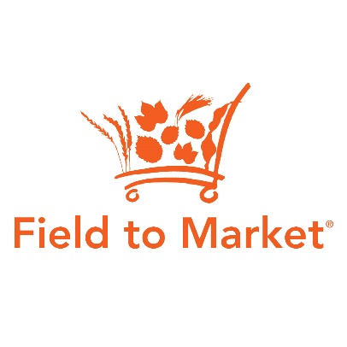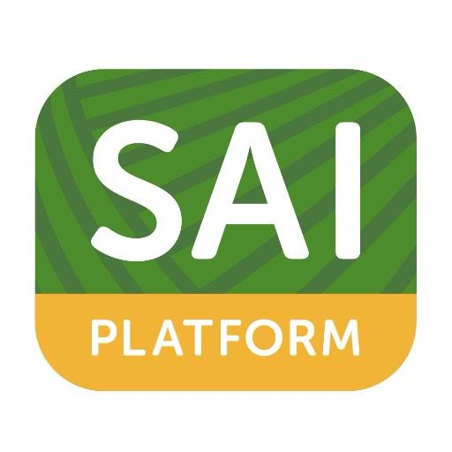

**Memorandum of Understanding***Field to Market: The Alliance for Sustainable Agriculture  
 and the Sustainable Agriculture Initiative Platform*

**Statement of Purpose**

The global population is growing rapidly, placing enormous demands on the world's food supply and our limited natural resources. Throughout the global agricultural supply chain - from farms to consumers – the need to protect natural resources and promote long-term community well-being and economic viability has never been more important. lt is essential to ensure efficient and sustainable production that protects environmental resources, and ensures the social and economic well-being of farmers and rural communities. Stakeholders across the global agricultural supply chain must work together to efficiently and responsibly lay the groundwork for the future.

**About Field to Market**

Field to Market®: The Alliance for Sustainable Agriculture is a diverse alliance working to create opportunities across the agricultural supply chain for continuous improvements in productivity, environmental quality, and human well-being. The multi-stakeholder organization provides collaborative leadership that is engaged in industry-wide dialogue, grounded in science, and open to the full range of technology choices. Field to Market is working to meet the challenge of producing enough food, fiber and fuel for a rapidly growing population while conserving natural resources and improving the ability of future generations to meet their own needs. Field to Market provides useful measurement tools and resources for growers and the supply chain that track and create opportunities for continuous improvement at the farm level. The program promotes a voluntary, collaborative approach to sustainability that is expressly science based, technology neutral and focused on outcomes that are within a growers control.

**About SAI Platform**

*[Please insert]  
Global scope*

*Questionnaire approach*

*Inclusion of social and economic considerations in addition to environmental*

**An Opportunity for Collaboration**

While each organization maintains their own strategies and approaches for achieving improved

sustainability performance, creating a roadmap of how our work can build on each other's will drive greater success for both organizations. Field to Market is focused on the unique challenges and environmental opportunities for commodity crop production in the United States, while SAI Platform aims to provide a global standard for a broader scope of sustainability concerns and crop systems. Both programs provide tools for companies to use to incentivize and demonstrate sustainability in their sourcing of agricultural products for food, fiber, feed and fuel.

Field to Market is focused on continuous improvement for commodity crop supply chains in the United States by enrolling farmers in the use of outcomes-based metrics through the Fieldprint® Platform (FPP). The FPP is a metrics based farm sustainability tool that collects information from growers on 80-120 questions for their operations in a given year for a specific crop. This information is used in the calculation of 8 sustainability indicators - Land Use, Irrigated Water Use, Water Quality, Energy Use, Greenhouse Gas Emissions, Soil Carbon, Soil Conservation and Biodiversity. Users are provided with their indicator results as well as input data and benchmark values to compare their performance against. It is specific to the USA, covering [corn](https://www.fieldtomarket.org/report/national-2/FINAL_Fact_Sheet-Env_Results_Corn_081913.pdf), [cotton](https://www.fieldtomarket.org/report/national-2/FINAL_Fact_Sheet-Env_Results_Cotton_081913.pdf), [potatoes](https://www.fieldtomarket.org/report/national-2/FINAL_Fact_Sheet-Env_Results_Potatoes_081913.pdf), [rice](https://www.fieldtomarket.org/report/national-2/FINAL_Fact_Sheet-Env_Results_Rice_081913.pdf), [soybean](https://www.fieldtomarket.org/report/national-2/FINAL_Fact_Sheet-Env_Results_Soy_081913.pdf), and [wheat](https://www.fieldtomarket.org/report/national-2/FINAL_Fact_Sheet-Env_Results_Wheat_081913.pdf) crops (with alfalfa, sugar beets, corn silage, barley and peanuts to be added in the next 12-24 months). The Field to Market program aims to identify areas for improvement in environmental outcomes for the producer based on comparison of their scores against benchmarks, against their own fields over time, and against other fields in their region. It is designed to be implemented via an online interface or farm management software. It is typically used in the context of a group project with professional crop advisors assisting in data entry, results analysis and guidance on practice changes to improve on metric outcomes.

The SAI Platform FSA is a set of 112 sustainable farm management questions that are applicable globally for all crops. It aims to become the industry reference for sustainable agriculture, replacing the largely repetitive and sometimes conflicting company codes. It is designed to be implemented through benchmarking and farmer self-assessment with or without 3rd party verification. The long term strategy for the FSA is to remain primarily qualitative, but add metrics indicators for monitoring and evaluation purposes and farmer comparative analysis.

With this MOU, Field to Market and SAI Platform demonstrate collaboration and an increase in the strategic use of our members' resources through joint respect for and coordination of our efforts. At the core of each organization is a commitment to a positive impact on people and the planet. Given the limited resources of each organization and its members, and the potential overlap of efforts for commodity crop production and supply chains in the United States, it is imperative that we not only avoid duplication but leverage each organization's respective strengths.

While the FPP is designed to concentrate on key issues of concern in US agriculture and has become the standard for sustainable commodity sourcing from US farmers, we recognize that many organizations using the FPP in the United States also have global sustainable agriculture programs and objectives. By ensuring that FPP efforts can be applied towards the FSA, we enable collaborative and harmonized sustainable sourcing strategies.

**Equivalency of Sustainability Platforms**

Through this MOU, the SAI Platform and Field to Market are instituting a program of equivalency by which use of the Fieldprint Platform in the United States can be used to help meet the requirements of the global FSA program. The FSA program establishes tiered performance thresholds: Bronze, Silver and Gold. In contrast, the FPP provides a standard methodology for measurement and uses a principle of continuous improvement from a baseline condition rather than establishing performance thresholds, which are often variable by crop, geography and climatic variability. In addition, the FSA program requires individual farmer responses on a range of social and economic questions designed to ensure fair labor and worker safety, and other social well-being factors associated with agricultural production.

Recognizing that the legal and regulatory framework for agriculture in the United States is robust, the two organizations have conducted a benchmarking process to a) determine the gaps between the two tools, b) determine the extent to which these gaps are adequately addressed by compliance with US national and state level laws and regulations, and c) establish a list of additional questions for FPP users to fill the gap. The results of the benchmarking in the form of required additional questions are included in Appendix A.

Initial implementation of the equivalency program will require FPP users to complete a spreadsheet of 15 additional questions. Response to these questions will determine whether the user achieves the Bronze, Silver or Gold level of equivalency with the FSA. By implementing this equivalency program, Field to Market member organizations have easier access to participate in the FSA as a means of achieving a global standard for their sustainability goals. Use of the supplemental questions in Appendix A should be considered voluntary for Field to Market member organizations and should be employed in those specific instances when equivalency with the SAI Platform is desired.   
   
**Governance of the MOU**

These activities, and more that may arise, will have the full support of each organizations' leadership team and Board of Directors. Annually, the executives and staffs from both organizations will meet via teleconference or in person to define an engagement plan to guide MOU activities and deliverables.

The staff of each organization will check-in quarterly to review progress and create joint updates that they may distribute to their respective Boards and membership. A series of talking points and Frequently Asked Questions about our collaboration will be generated so that we may both communicate about this work as supported by our partnership.

The collaboration set forth under this MOU may be terminated at any time by either party; however, prior to any such termination, if at any time the organizations are in disagreement about the scope of activity or direction of the joint collaboration a discussion between the organizational leadership of each group should ensue and plans should be agreed before either party dissolves the collaboration and terminates this MOU.

As we expect this relationship to grow, not dissolve, discussion may also ensue about additional joint activities the organizations may take on and construct under the broad terms of this MOU.

No funding is being provided under this MOU. SAI Platform and Field to Market are acting as independent contractors under this MOU, and nothing in this MOU should be deemed to create an agency, partnership or joint venture between the parties. Any confidential information to be exchanged by the parties will be done under the protection of an appropriate confidentiality and non-disclosure agreement executed by the parties. Each party agrees to indemnify, defend and hold the other party harmless from and against any claim arising from such party's actions in the conduct of the activities contemplated under this MOU.

Signed,

____________________

Rod Snyder  
President  
Field to Market: The Alliance for Sustainable Agriculture

____________________

Date

____________________

Peter-Erik Ywema  
Executive Director  
SAI Platform

____________________

Date