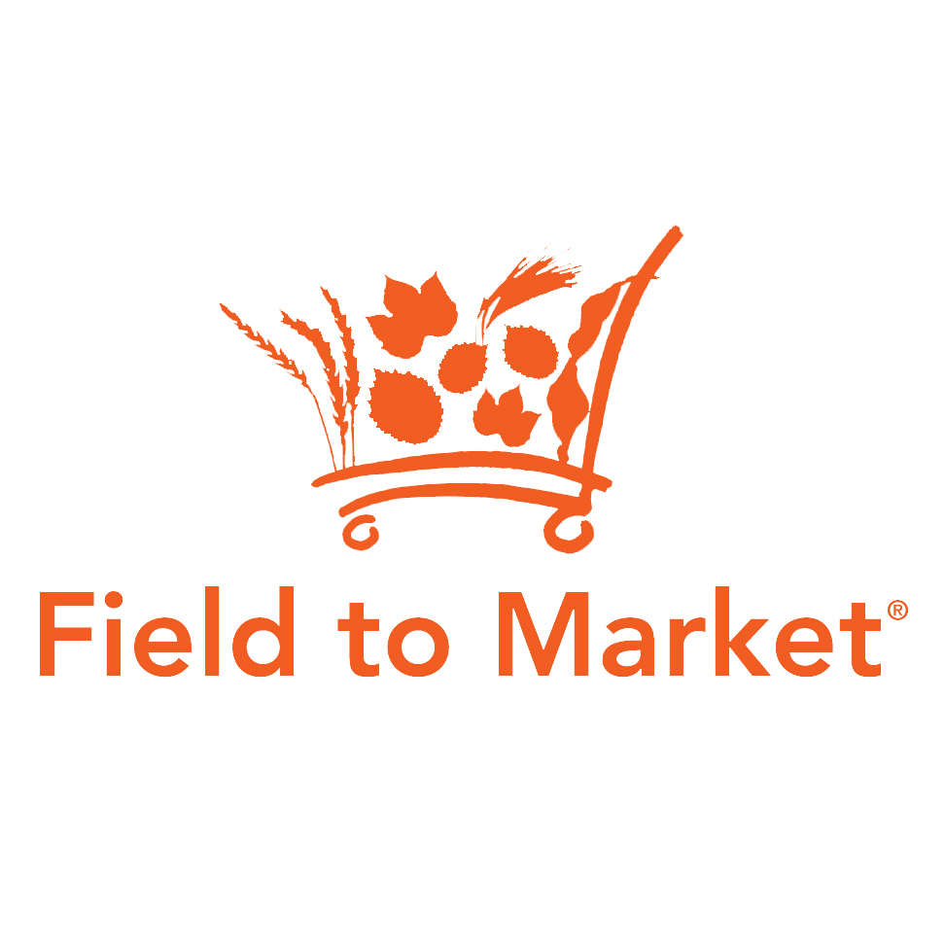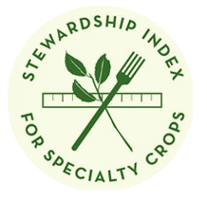

*Draft MOU concept between* **Field to Market: The Alliance for Sustainable Agriculture  
and the Stewardship Index for Specialty Crops**

The following principles would provide the impetus for the MOU and all future collaboration:

* Ease of use for growers and supply chain partners – How can the two organizations help facilitate seamless data collection, aggregation and sharing for growers and supply chain partners who grow/use both specialty crops and commodities?
* A common sustainability framework for US agriculture – How can the two organizations combine efforts to strengthen a common/consistent framework for supply chain sustainability?

The following topics provide the potential areas of alignment between the two organizations:

* Consider and explore, where possible, how the two organizations can harmonize or align metrics.
* Consider and explore, where possible, how the two organizations can collaborate to bring common technology and data collection solutions.
* Consider and explore, where possible, how the two organizations can share common verification protocols.
* Consider and explore, where possible, how the two organizations can partner and align in governance.