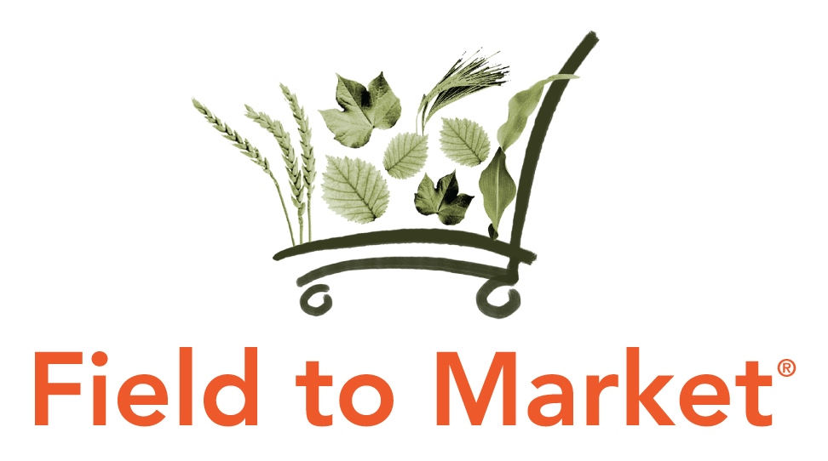
Field to Market: The Alliance for Sustainable Agriculture
Board of Directors Meeting
January 10-11, 2017
Washington, DC
Agenda

Location: World Wildlife Fund, 1250 24th Street, NW, Washington DC 20037
Dial-in: 800-974-2164; Code 24580724#
Webinar: https://fieldtomarket.adobeconnect.com/ftmbodjan2017/

Tuesday, January 10

12:00 p.m. | Lunch available
12:30 p.m. | Welcome, introductions and anti-trust reminder
12:35 p.m. | Review and approval of November minutes (VOTE REQUIRED)
12:40 p.m. | Finance and operations update  - Update on 2016 financials through November  - 2017 staffing plans  - Feedback on 2016 Sustainable Ag Summit
12:55 p.m. | Membership update  - Review and approval of new FTM members (VOTE REQUIRED)  - Keystone Policy Center (Affiliate)  - Mars (Full – Food/Retail) pending  - Michigan State University (Affiliate)  - Schedule for 2017 dues invoicing  - Affiliate Sector update
1:10 p.m. | Communications update  - Media impressions and outreach opportunities  - Update on new website and member portal rollout
1:30 p.m. | Verification Program Development: Board Work Session  - Proposed impact verification cycles  - Accounting systems for volumes and downstream claims  - Verification roles
3:15 p.m. | Break
3:30 p.m. | Verification Program Development: Board Work Session (continued)  - Verification documentation required  - Continuous Improvement Plan  - Case studies
5:30 p.m. | Adjourn
6:00 p.m. | Dinner  Grillfish DC (1200 New Hampshire Ave, NW)

Wednesday, January 11

8:30 a.m. | Breakfast available
9:00 a.m. | Review FTM’s 2017 Work Plan (VOTE REQUIRED)
9:45 a.m. | Discuss continuing evolution/refinement of FTM’s business plan
10:15 a.m. | Break
10:30 a.m. | NRCS Conservation Innovation Grant application  - Proposed timeline and deliverables  - Proposed budget and match  - Supporting organizations
11:30 a.m. | Data and technology updates  - Data management partner announcement  - API capacity testing and platform updates  - Piloting new alfalfa module  - Tech Advisory Council updates  - Fieldprint Platform 3.0 RFP process and timeline  - Key 3.0 platform improvement areas  - Policy considerations: bidding on 3.0, intellectual property implications, open source discussion, etc.
12:30 p.m. | Lunch
1:00 p.m. | Harmonization and alignment updates  - SAI Platform MOU announcement  - Potential MOU with the Stewardship Index for Specialty Crops (VOTE REQUIRED)  - Draft guidance for responding to TSC KPIs
1:45 p.m. | Overview of new crops / stages of implementation  - Alfalfa, sugar beets, peanuts, corn silage, sorghum, and barley
2:15 p.m. | Fieldprint Projects  - Overview of registered projects  - Review new member portal functionality
2:45 p.m. | Education and Outreach Committee updates  - Fieldprint Project Manual and Best Management Methodology Report  - Training/resource needs for crop advisors, ag retailers, etc.  - Case studies on correlation between sustainability outcomes and economic impacts
3:05 p.m. | Metrics Committee updates  - Council for Agricultural Science and Technology (CAST) proposed paper on FTM (VOTE REQUIRED)  - Water quality metric report  - N2O revisions  - Other subgroup updates
4:00 p.m. | Awards and Recognition Committee updates  - Upcoming Farmer Spotlight nomination deadlines  - Review framework for 2017 Awards Program
4:15 p.m. | Review 2017 meeting schedule
4:30 p.m. | Adjourn

